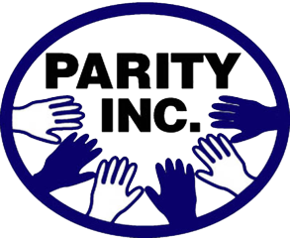

TOP TEN NOMINATION FORM

Parity Inc. is a program of citizen participation that addresses issues and problems of fairness and equity in the African-American community. The overall mission is to improve the economics, educational and social conditions of African-Americans in order to gain parity with the majority community.

Nominee’s Full Name
Nominee’s Business Title (if applicable)
Company/Business Name (if applicable)
Nominee’s Mailing Address
Nominee’s Telephone (cell)
Nominee’s Telephone (home or office)
Nominee’s E-mail

Platform of Influence: Briefly illustrate how the nominee has used his platform of influence within the Greater Dayton community to pave a brighter path for future generations of African-Americans (e.g., activist, community leader, elected official, religious leader, and so forth).

Present Community Involvement: Briefly illustrate how the nominee has used his talents as a volunteer within the Greater Dayton community to pave a brighter path for future generations of African-Americans (response should include time and quality of the participation devoted to these efforts).

Leadership Experience: Briefly illustrate how the nominee has distinguished himself as an exemplary African-American role model in their respective community or employment.

Family Response: Briefly illustrate how the nominee has distinguished himself as a leader within their family and the community through civic engagement.

Nominator Name
Nominator Telephone (Cell)
Nominator Telephone (Home or Office)
Nominator E-mail

(Type nomination package with 1-inch margins, 11-12 font size, and with Arial or Times New Roman font)
(Limit each response to 2,000 characters and use a bullet point or summary paragraph format)
(Attach any additional information – biography, resume or other data – and limit to 3 pages or less)

The application deadline is at midnight on Monday, November 11, 2019. You may return the application by mail to the Parity, Inc office at PO Box 60624, Dayton, Ohio 45406 or e-mail the form to: paritydayton@aol.com. If you have any questions please feel free to call 937-228-3939.

The 2019 Top 10 African American Luncheon is scheduled on February 20, 2020 from 11:30 am to 1:00 pm at Sinclair Community College.

